AT ACS ONLY:
Get a free FUSE USB drive when you do one of the following*:

Take the FUSE Exam at ACS
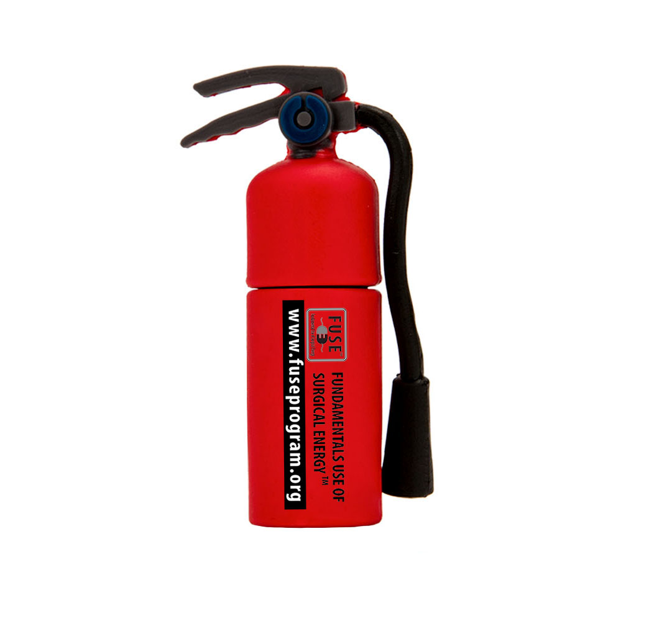

OR

Register for a FUSE Exam date between October and January

Email info@fuseprogram.org for assistance

*Valid until October 8, 2015 while supplies last. Limit 1 per person.

